**Sunderland Prevention Offer for Children and Young People**

**Educational Settings**

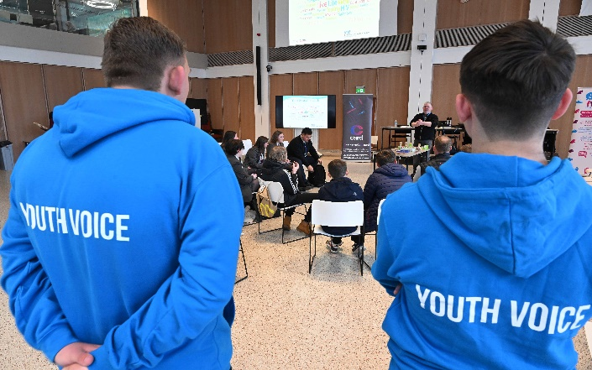

**Contents**

Introduction 3

Theme 1 Staying safe and personal development 7

Theme 2 Mental health and wellbeing 16

Theme 3 Drugs, alcohol and smoking 24

Theme 4 Maintaining a healthy weight 27

**Introduction**

The **Sunderland City Plan** sets out a vision for Sunderland to be a Vibrant, Dynamic and Healthy City by 2030, whereby Sunderland will be a connected, international city with opportunities for all.

|  |  |  |
| --- | --- | --- |
| ***Dynamic City*** | ***Healthy City*** | ***Vibrant City*** |
| * more local people with better qualifications and skills to enable them to participate in and benefit from a stronger economy. | * access to the same opportunities and life chances * more people living healthier longer lives | * more residents participating in their communities * more people feel safe in their neighbourhoods and homes * more resilient people |

It provides the blueprint for all partners and communities to work together to achieve our shared economic and social ambitions for Sunderland, including engaging children and young people in improving their health and wellbeing and contributing to the city to enable it and its people to achieve their full potential.

The [Sunderland Healthy City Plan - Sunderland City Council](https://www.sunderland.gov.uk/healthycityplan) is our refreshed Joint Health and Wellbeing Strategy, informed by insight and intelligence gained through our Joint Strategic Needs Assessment. It supports the delivery of the City Plan, addressing the interlinked challenges that exist between good health and other key issues in the city. The nine workstreams include:

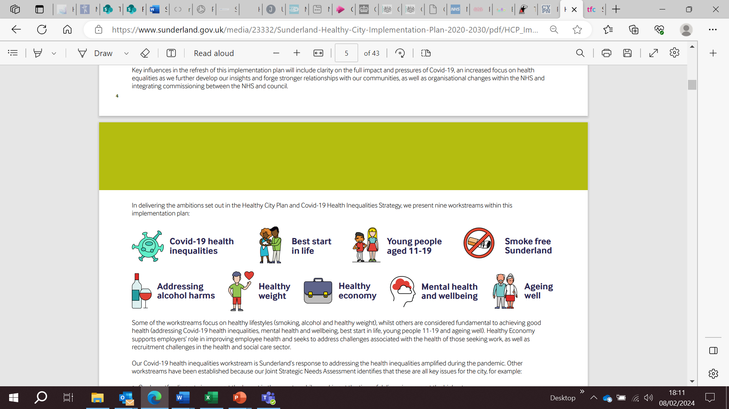

Both plans are underpinned by other strategies that direct and inform the planning and delivery to achieve health and wellbeing outcomes for children and young people in the City.

**Prevention and Early Help**

Prevention is about supporting all children and young people to grow up happy, healthy, safe and resilient, by providing them with the knowledge and skills they need to manage the opportunities and challenges that may come their way. Prevention is a key principle of children’s safeguarding, where it is better to take action before harm occurs.

From September 2021, it became a statutory requirement to provide Relationships and Health Education in primary schools and Relationship and Sex and Health Education in all secondary schools in England (RSHE). Many schools are already offering high quality RSHE that covers, and exceeds, statutory content. The content of the RSHE curriculum delivered should support the wider work of the whole school environment.

The [Working together to safeguard children - GOV.UK](https://www.gov.uk/government/publications/working-together-to-safeguard-children--2) (2023) definition of safeguarding now includes early help. [Keeping children safe in education 2024](https://assets.publishing.service.gov.uk/media/66d7301b9084b18b95709f75/Keeping_children_safe_in_education_2024.pdf) states that all staff should be aware of their local early help process, understand their role in it and be prepared to identify children who may benefit from early help[1]. Therefore, if your setting is not offering early help, they are not following safeguarding guidance. Early help means providing support as soon as a problem emerges at any point in a child’s life, from the foundation years through to the teenage years. The guidance also highlights that professionals should be aware of the boundaries and limitations of their role; remembering that children and young people often require a listening ear, which can enable them to navigate the system and ensure they are supported to access correct information or the appropriate specialist services and support.

The Sunderland Prevention Offer has been developed to support professionals working with children and young people in educational and community settings. It provides information on universal and targeted services available in the city, who can offer early intervention or specialist support to reduce or prevent problems or issues from getting worse and bring in the right support at the right time to meet children and young people’s needs.

All organisations across the city that work with children and young people can access support or make referrals for individuals or groups of children and young people who may be at risk of and/or engaging in risk taking behaviours that could impact on their physical and mental health, wellbeing and personal safety.

The document is broken down into 4 themed areas and informs what key stage in education the services can work with. The themes are:

**Theme 1** Staying Safe and General Health and Wellbeing

**Theme 2** Mental Health and Wellbeing

**Theme 3** Drugs, Alcohol and Smoking

**Theme 4** Maintaining a Healthy Weight

**iThrive Model**

Similar to the Prevention and Early Help Strategy for Sunderland, the themes are aligned with the iThrive model of support, which is also based on four themes.

|  |  |  |  |
| --- | --- | --- | --- |
| **Prevention** | | **Early Help** | |
| **Thriving** | **Getting Advice** | **Getting Help** | **Getting More Help** |
| Providing access to information, advice and guidance. | Helping with access to local community support service and organisations. | Offering access to coordinated support at the earliest opportunity. | Delivering interventions to prevent issues escalating. |

***Please note: The services listed are not a replacement for delivering a school's statutory duty for RSHE, they are there to enhance a school’s offer and access to specialist support when a new and emerging issue arises in relation to health, wellbeing and risk-taking behaviour, or a targeted intervention is required.***

The Sunderland Prevention Offer for Children and Young People was developed in partnership with:

Sunderland City Council

* Public Health
* Active Sunderland Healthy Lifestyles Programme (formerly Change for Life Sunderland)
* Transportation and Infrastructure
* Sunderland Culture
* Libraries

Together for Children

* Youth Drug and Alcohol Project (YDAP)
* Careers and NEET Service
* Youth Offending Service Prevention (YOS)
* Sunderland Music Hub

NHS

* Growing Healthy Sunderland - 0-19 Public Health Service
* Healthy Heads
* Sunderland Community Children and Young People’s Mental Health Service (CCYPMHS)
* Children and Young People’s Service (CYPS)
* Sunderland Integrated Sexual Health Service
* Sunderland Stop Smoking Service

Sunderland Mind

Washington Mind

Northumbria Police

Rise North East

Royal National Lifeboat Institution

Tyne & Wear Fire & Rescue Service

1. Detailed information on early help can be found in Chapter 1 of [Working together to safeguard children - GOV.UK (www.gov.uk)](https://www.gov.uk/government/publications/working-together-to-safeguard-children--2)